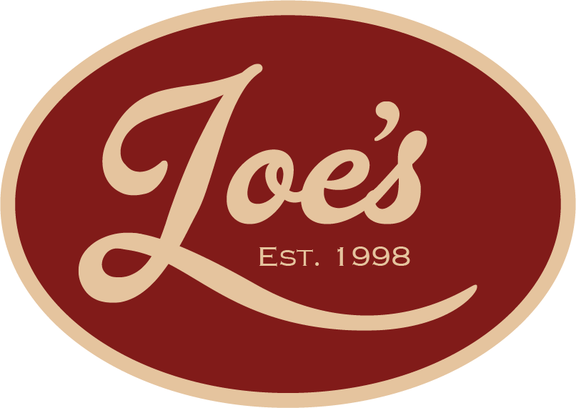

Christmas Menu 2025
Available from 1st-23rd December
STARTERS
Blue cheese, pear & walnut souffle, apple & real ale chutney
Beetroot-cured salmon, horseradish cream
Crispy pork belly, apple puree, parsnip crisps
Vegan walnut & mushroom pate, onion marmalade & toasted brioche

___________________________________________________________
MAINS
Roast Turkey roulade cranberry & sage stuffing, Fondant potatoes,
honey-glazed seasonal vegetables, brussels sprouts and gravy
Salmon wellington,
mushroom duxelles in puff pastry, ,sauteed new potatoes, broccolini, dill cream sauce
Goats cheese, pecan & beetroot salad honey-dijon vinaigrette
Nut roast fondant potatoes, roasted root vegetables, brussels sprouts & vegan gravy

____________________________________________________________
DESSERT
Christmas pudding vanilla Chantilly, brandy butter sauce
Sticky toffee pudding, honeycomb ice cream, toffee sauce
Chocolate brownie, chocolate sauce, clotted cream vanilla ice cream
Trio of ice cream / sorbets
2-course £30.00
3-course £37.50
Deposit of £10pp required to secure booking
Service @ 10% is added to the final bill
Pre-order may be required

